**Selamawit Muluneh _ Project proposal**

**Flight information database**

This is a database that customers can get to and book flights and it is also a database that can show flight status. An efficient and accessible database where flight status is updated frequently. It is accessed through a website. The website will consist of a home page and the website template will be flexible for future expansion and will be the first step in establishing a web presence.

The first step I took to design this database is to develop a schema that is the conceptual design phase. The conceptual design shows entities and the entity relationships they have with one another. Here I have examined the my attributes and avoid redundance by any chance.

I have identified the tables as

1.Flightinfo (Flight_ID, Airline_ID, Aircraft_ID, Stops, Price)

2. Flight (Flight_ID, Airline_ID, Stops, deptAirport, destAirport)

3. Airport(Airport_ID, Airport_name, City, Country)

4.Airline(Airline_ID, Airline_Name)

5.Aircraft(Aircraft_ID, Aircraft_model, Seats, Reastrooms)

The logical design consists of make sure that there is no redundance.

Redundacy creates inconsistence an a database because updating an attribute in one table might not update the same attribute in the other table. In my database I have the attribute stops in both Flightinfo table and Flight table. These is because I wanted this attribute to be shown in both tables as it is an important aspect of both tables. To avoid the inconsistence Stops in Flight table is referring to stops in Flightinfo table.

**schema**

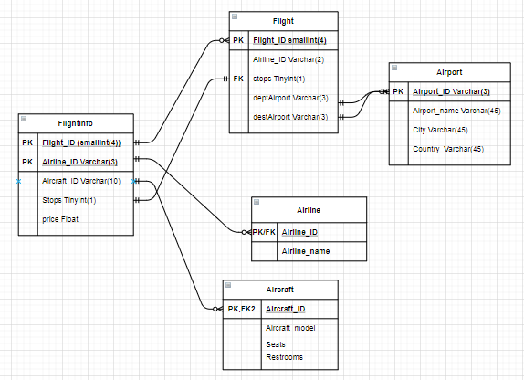

create table flightinfo

(Flight_ID varchar(4)unique,

Airline_ID varchar(3)unique,

Aircraft_ID varchar(10)unique,

Stops numeric(1),

Price numeric(5,2),

primary key (Flight_ID, Airline_ID,Aircraft_ID)

);

ALTER TABLE flightinfo

Add CONSTRAINT fk_Airline

FOREIGN KEY(Airline_ID)

REFERENCES Airline(Airline_ID)

ON DELETE SET NULL

ALTER TABLE flightinfo

Add CONSTRAINT fk_Aircraft

FOREIGN KEY(Aircraft_ID)

REFERENCES Aircraft(Aircraft_ID)

ON DELETE SET NULL

create table flight

(Flight_ID varchar(4) unique,

Airline_ID varchar(3),

Stops numeric(1),

deptAirport varchar(3),

destAirport varchar(3),

primary key (Flight_ID),

CONSTRAINT fk_flightinfo

FOREIGN KEY(Flight_ID)

REFERENCES flightinfo(Flight_ID)

ON DELETE SET NULL,

CONSTRAINT fk_Airport1

FOREIGN KEY(deptAirport)

REFERENCES Airport(Airport_ID)

ON DELETE SET NULL,

CONSTRAINT fk_Airport2

FOREIGN KEY(destAirport)

REFERENCES Airport(Airport_ID)

ON DELETE SET NULL

);

ALTER TABLE flight

Add CONSTRAINT fk_Stops

FOREIGN KEY(Stops)

REFERENCES flightinfo(Stops)

ON DELETE SET NULL

create table Airport

(Airport_ID varchar(3)unique,

Airport_name varchar(25),

City varchar(25),

Country varchar(15),

primary key (Airport_ID)

);

create table Airline

(Airline_ID varchar(3)unique,

Airline_name varchar(25),

primary key (Airline_ID)

);

create table Aircraft

(Aircraft_ID varchar(10)unique,

Aircraft_Model varchar(10),

Seats numeric(2),

Restrooms numeric(2),

primary key (Aircraft_ID)

);